Supplementary online material for Spurgin et al. ‘Genetic and phenotypic divergence in an island bird: isolation by distance, by colonisation or by adaptation?’
Appendix 1 Sources for climate variables used to calculate ‘environmental distance’ across Berthelot’s pipit populations
Island | Annual rainfall | August temperature (ºC) | January temperature (ºC)
Deserta Grande | 631.9 | 24 | 17
El Hierro | 353 | 23 | 18
Fuerteventura | 120 | 24 | 18
Gran Canaria | 300 | 24 | 18
La Gomera | 370 | 24 | 18
La Graciosa | 150 | 25 | 17
Lanzarote | 156 | 25 | 17
Madeira | 1711 | 23 | 16
La Palma | 740 | 24 | 18
Porto Santo | 379 | 23 | 16
Selvagen Grande | 292 | 24 | 17
El Teide | 441 | 18 | 4
Tenerife | 425 | 23 | 16

Sources
Canary Islands
http://www.gevic.net/info/capitulos_cat.php?idcategoria=22
http://izana.aemet.es/index.php?option=com_content&view=article&id=252:precipitation-at-izana-for-the-hydrological-year-2010-2011&catid=10:news&Itemid=49&lang=es

Madeira
Lima & Lima (2009)

Selvagens
J.C. Illera (Unpublished data, collected 2002, 2003 and 2004)

Table S1 Demographic scenarios used for approximate Bayesian computation (ABC) analyses (see Figure 1 for visual representation). All priors were given uniform distributions, with minimum and maximum values presented.
 | Scenario 1 | Scenario 2 | Scenario 3 | Scenario 4
Colonisation | Simultaneous | Simultaneous | Stepping stone | Stepping stone
Bottleneck | Yes | No | Yes | No
Parameter
N_{e}
Canary Islands | 10-10⁵ | 10-10⁵ | 10-10⁵ | 10-10⁵
Selvagens | 10-500 | 10-500 | 10-500 | 10-500
Madeira | 10-10⁴ | 10-10⁴ | 10-10⁴ | 10-10⁴
Colonisation time (generations ago)
Canary Islands | 10³-10⁶ | 10³-10⁶ | 10³-10⁶ | 10³-10⁶
Selvagens | 500-10⁵ | 500-10⁵ | 500-10⁵ | 500-10⁵
Madeira | 500-10⁵ | 500-10⁵ | 500-10⁵ | 500-10⁵
N_{e} during bottleneck
Canary Islands | - | - | - | -
Selvagens | 1-50 | - | 1-50 | -
Madeira | 1-50 | - | 1-50 | -
Bottleneck duration
Canary Islands | 1-10⁴ | - | 1-10⁴ | -
Selvagens | 1-10⁴ | - | 1-10⁴ | -
Madeira | 1-10⁴ | - | 1-10⁴ | -

Table S2 Twenty-one microsatellite loci characterised in the Berthelot’s pipit.

Locus |  | GenBank  accession number | Reference
TG01-047 |  | CK315344 | (Dawson et al. 2010)
TG02-088 |  | DV579347 | (Dawson et al. 2010)
TG03-002 |  | DV575298 | (Dawson et al. 2010)
TG03-098 |  | DV573670 | (Dawson et al. 2010)
TG04-004 |  | DV946288 | (Dawson et al. 2010)
TG05-053 |  | CK314425 | (Dawson et al. 2010)
TG06-009 |  | CK315728 | (Dawson et al. 2010)
TG09-014 |  | DV948892 | (Dawson et al. 2010)
TG13-009 |  | DV948691 | (Dawson et al. 2010)
CAM-02 |  | HG518760 | (Dawson et al. 2013)
CAM-04 |  | HG518762 | (Dawson et al. 2013)
CAM-08 |  | HG518766 | (Dawson et al. 2013)
CAM-13 |  | HG518771 | (Dawson et al. 2013)
CAM-18 |  | HG518776 | (Dawson et al. 2013)
CAM-23 |  | HG518781 | (Dawson et al. 2013)
Pdoµ5 |  | Y15126 | (Dawson et al. 2012)
Pdo46 |  | AM159026 | (Dawson et al. 2012)
Pdo47 |  | AM159027 | (Dawson et al. 2012)
HrU5 |  | X84090 | (Primmer et al. 1995)
Pca7 |  | AJ279809 | (Dawson et al. 2000)
Ppi2 |  | AJ272375 | (Martinez et al. 1999)

Table S3 Allele frequencies at 21 microsatellite loci across island populations of Berthelot’s pipit. SG: Selvagem Grande, DG: Deserta Grande, M: Madeira, PS: Porto Santo, EH: El Hierro, PAL: La Palma, GOM: La Gomera, TEID: El Teide, TF: Tenerife, GC: Gran Canaria, FV: Fuerteventura, LZ: Lanzarote, GRAC: La Graciosa.
Locus | Allele | SG | DG | M | PS | EH | PAL | GOM | TEID | TF | GC | FV | LZ | GRAC
TG03-002 | 1 | - | 0.103 | 0.18 | 0.192 | 0.15 | 0.056 | 0.117 | 0.069 | 0.1 | - | 0.067 | 0.05 | -
 | 2 | 1 | 0.293 | 0.46 | 0.308 | 0.75 | 0.759 | 0.767 | 0.845 | 0.767 | 0.793 | 0.85 | 0.85 | 0.935
 | 3 | - | 0.017 | 0.02 | 0.154 | 0.083 | 0.13 | 0.1 | 0.086 | 0.133 | 0.172 | 0.083 | 0.1 | 0.065
 | 4 | - | 0.431 | 0.26 | 0.346 | 0.017 | 0.056 | 0.017 | - | - | 0.017 | - | - | -
 | 5 | - | - | 0.08 | - | - | - | - | - | - | 0.017 | - | - | -
 | 6 | - | 0.155 | - | - | - | - | - | - | - | - | - | - | -
TG13-009 | 1 | 1 | 0.828 | 0.688 | 0.673 | 0.914 | 0.962 | 0.897 | 0.926 | 0.967 | 0.821 | 0.95 | 0.87 | 0.826
 | 2 | - | 0.172 | 0.313 | 0.327 | 0.086 | 0.038 | 0.103 | 0.074 | 0.033 | 0.179 | 0.05 | 0.13 | 0.174
TG01-047 | 1 | 0.893 | 0.883 | 0.96 | 0.981 | 0.8 | 0.648 | 0.786 | 0.607 | 0.75 | 0.607 | 0.683 | 0.615 | 0.891
 | 2 | 0.107 | 0.117 | 0.04 | 0.019 | 0.2 | 0.352 | 0.214 | 0.393 | 0.25 | 0.393 | 0.317 | 0.385 | 0.109
TG02-088 | 1 | 1 | 1 | 1 | 1 | 1 | 0.981 | 0.958 | 1 | 0.981 | 1 | 0.933 | 0.962 | 0.933
 | 2 | - | - | - | - | - | 0.019 | 0.042 | - | 0.019 | - | 0.067 | 0.038 | 0.067
TG03-098 | 1 | - | - | - | - | 0.35 | 0.13 | 0.411 | 0.089 | 0.214 | 0.259 | 0.259 | 0.154 | 0.13
 | 2 | 0.357 | 0.042 | 0.075 | 0.043 | 0.233 | 0.093 | 0.125 | 0.232 | 0.107 | 0.086 | 0.259 | 0.269 | 0.022
 | 3 | 0.643 | 0.958 | 0.925 | 0.957 | 0.417 | 0.778 | 0.464 | 0.679 | 0.679 | 0.655 | 0.483 | 0.577 | 0.848
TG04-004 | 1 | - | - | 0.021 | - | 0.1 | 0.143 | 0.31 | 0.172 | 0.1 | 0.172 | 0.155 | 0.183 | 0.196
 | 2 | 1 | 0.517 | 0.646 | 0.788 | 0.75 | 0.804 | 0.655 | 0.759 | 0.867 | 0.724 | 0.776 | 0.7 | 0.717
 | 3 | - | 0.483 | 0.333 | 0.212 | 0.15 | 0.018 | 0.034 | 0.069 | 0.033 | 0.069 | 0.052 | 0.05 | 0.065
 | 4 | - | - | - | - | - | 0.036 | - | - | - | 0.034 | 0.017 | 0.067 | 0.022
TG09-014 | 1 | - | - | - | - | - | 0.019 | - | - | - | - | - | - | -
 | 2 | - | 0.172 | 0.065 | - | 0.017 | 0.115 | 0.069 | 0.052 | 0.1 | 0.034 | 0.107 | 0.052 | 0.109
 | 3 | 0.517 | 0.414 | 0.391 | 0.417 | 0.267 | 0.288 | 0.19 | 0.155 | 0.183 | 0.224 | 0.107 | 0.155 | 0.065
 | 4 | 0.328 | 0.138 | 0.239 | 0.146 | 0.267 | 0.077 | 0.224 | 0.207 | 0.167 | 0.138 | 0.214 | 0.276 | 0.217
 | 5 | 0.034 | - | - | - | 0.017 | - | - | - | - | - | 0.018 | 0.017 | -
 | 6 | 0.121 | 0.224 | 0.261 | 0.25 | 0.283 | 0.154 | 0.121 | 0.172 | 0.317 | 0.31 | 0.143 | 0.207 | 0.022
 | 7 | - | 0.052 | 0.043 | 0.188 | 0.133 | 0.288 | 0.379 | 0.379 | 0.217 | 0.276 | 0.375 | 0.276 | 0.565
 | 8 | - | - | - | - | - | 0.019 | 0.017 | 0.034 | 0.017 | - | - | 0.017 | 0.022
 | 9 | - | - | - | - | 0.017 | 0.038 | - | - | - | 0.017 | 0.036 | - | -
TG05-053 | 1 | - | - | - | - | - | - | - | - | - | 0.018 | - | 0.018 | 0.065
 | 2 | - | - | - | - | 0.017 | 0.04 | 0.183 | 0.056 | 0.067 | 0.018 | 0.083 | 0.036 | 0.022
 | 3 | 1 | 1 | 1 | 0.864 | 0.567 | 0.58 | 0.367 | 0.556 | 0.567 | 0.482 | 0.5 | 0.518 | 0.696
 | 4 | - | - | - | 0.136 | 0.417 | 0.38 | 0.45 | 0.389 | 0.35 | 0.482 | 0.417 | 0.429 | 0.217
 | 5 | - | - | - | - | - | - | - | - | 0.017 | - | - | - | -
TG06-009 | 1 | 0.817 | 0.183 | 0.558 | 0.288 | 0.733 | 0.704 | 0.867 | 0.804 | 0.75 | 0.845 | 0.517 | 0.724 | 0.717
 | 2 | 0.183 | 0.55 | 0.442 | 0.712 | 0.267 | 0.278 | 0.117 | 0.196 | 0.25 | 0.155 | 0.467 | 0.276 | 0.283
 | 3 | - | 0.267 | - | - | - | 0.019 | 0.017 | - | - | - | 0.017 | - | -
Pca7 | 1 | 1 | 1 | 1 | 1 | 0.967 | 0.804 | 0.917 | 0.948 | 0.9 | 0.966 | 0.95 | 0.85 | 0.826
 | 2 | - | - | - | - | 0.033 | 0.196 | 0.083 | 0.052 | 0.1 | 0.034 | 0.05 | 0.15 | 0.174
CAM-13 | 1 | 0.768 | 0.56 | 0.5 | 0.643 | 0.9 | 0.907 | 0.948 | 0.857 | 0.85 | 0.875 | 0.933 | 0.926 | 0.87
 | 2 | 0.232 | 0.16 | 0.167 | - | 0.1 | 0.093 | 0.052 | 0.143 | 0.15 | 0.125 | 0.067 | 0.074 | 0.13
 | 3 | - | 0.28 | 0.333 | 0.357 | - | - | - | - | - | - | - | - | -
Pdo46 | 1 | - | 0.05 | 0.06 | - | 0.05 | - | - | 0.018 | 0.033 | 0.017 | - | - | -
 | 2 | 0.31 | 0.95 | 0.9 | 1 | 0.783 | 0.714 | 0.717 | 0.857 | 0.733 | 0.776 | 0.75 | 0.852 | 0.739
 | 3 | - | - | 0.04 | - | 0.083 | 0.232 | 0.183 | 0.107 | 0.083 | 0.155 | 0.217 | 0.093 | 0.196
 | 4 | - | - | - | - | - | - | - | - | 0.017 | - | - | - | -
 | 5 | 0.69 | - | - | - | 0.067 | 0.054 | 0.1 | - | 0.117 | 0.034 | 0.033 | 0.037 | 0.065
 | 6 | - | - | - | - | 0.017 | - | - | 0.018 | 0.017 | 0.017 | - | 0.019 | -
CAM-02 | 1 | 1 | 0.357 | 0.188 | 0.34 | 0.25 | 0.482 | 0.217 | 0.304 | 0.276 | 0.19 | 0.35 | 0.36 | 0.087
 | 2 | - | - | - | - | - | - | 0.017 | 0.018 | 0.069 | - | 0.017 | - | 0.043
 | 3 | - | 0.161 | 0.063 | 0.04 | 0.033 | 0.054 | 0.083 | 0.018 | 0.034 | 0.052 | 0.033 | 0.02 | 0.217
 | 4 | - | - | - | - | - | - | 0.033 | - | - | - | - | - | -
 | 5 | - | 0.089 | 0.083 | 0.1 | 0.2 | 0.125 | 0.25 | 0.268 | 0.224 | 0.19 | 0.233 | 0.04 | 0.196
 | 6 | - | - | - | - | 0.05 | - | - | - | - | - | - | - | -
 | 7 | - | - | 0.021 | - | 0.133 | 0.107 | 0.167 | 0.125 | 0.086 | 0.121 | 0.1 | 0.16 | 0.065
 | 8 | - | - | - | - | 0.033 | 0.054 | 0.067 | 0.054 | 0.034 | 0.052 | 0.017 | 0.06 | 0.065
 | 9 | - | 0.375 | 0.417 | 0.5 | 0.05 | 0.036 | - | 0.054 | 0.034 | 0.052 | 0.033 | 0.04 | 0.043
 | 10 | - | - | - | - | - | 0.036 | 0.05 | 0.018 | 0.086 | 0.103 | - | - | -
 | 11 | - | 0.018 | 0.229 | 0.02 | 0.133 | 0.071 | 0.067 | 0.107 | 0.069 | 0.172 | 0.183 | 0.18 | 0.065
 | 12 | - | - | - | - | 0.067 | - | - | 0.018 | 0.052 | 0.034 | - | 0.06 | -
 | 13 | - | - | - | - | 0.033 | 0.036 | - | 0.018 | 0.017 | 0.017 | 0.017 | 0.06 | 0.217
 | 14 | - | - | - | - | 0.017 | - | 0.05 | - | 0.017 | 0.017 | 0.017 | 0.02 | -
CAM-23 | 1 | - | - | - | - | 0.1 | 0.089 | 0.1 | 0.017 | 0.1 | 0.034 | 0.083 | - | -
 | 2 | - | - | - | - | - | 0.054 | - | - | - | - | - | - | -
 | 3 | - | - | - | - | 0.017 | 0.036 | 0.017 | 0.034 | 0.017 | 0.052 | 0.05 | 0.115 | -
 | 4 | - | - | - | - | - | - | - | - | - | 0.052 | - | 0.038 | 0.087
 | 5 | - | - | - | - | - | 0.018 | - | 0.017 | 0.083 | 0.017 | - | 0.038 | 0.043
 | 6 | 0.414 | - | - | - | 0.067 | 0.089 | 0.3 | 0.31 | 0.267 | 0.224 | 0.217 | 0.154 | 0.348
 | 7 | - | - | - | - | 0.067 | 0.036 | - | - | - | - | 0.033 | 0.019 | -
 | 8 | 0.517 | 0.259 | 0.458 | 0.6 | 0.633 | 0.464 | 0.333 | 0.293 | 0.333 | 0.414 | 0.3 | 0.365 | 0.217
 | 9 | 0.069 | 0.741 | 0.542 | 0.4 | 0.083 | 0.125 | 0.217 | 0.19 | 0.1 | 0.103 | 0.2 | 0.173 | 0.152
 | 10 | - | - | - | - | - | 0.054 | 0.033 | 0.103 | 0.05 | 0.034 | 0.067 | 0.038 | 0.043
 | 11 | - | - | - | - | 0.033 | - | - | 0.017 | 0.05 | 0.017 | 0.05 | 0.058 | 0.109
 | 12 | - | - | - | - | - | 0.036 | - | 0.017 | - | - | - | - | -
 | 13 | - | - | - | - | - | - | - | - | - | 0.017 | - | - | -
 | 14 | - | - | - | - | - | - | - | - | - | 0.034 | - | - | -
CAM-04 | 1 | 0.638 | - | 0.02 | - | 0.267 | 0.25 | 0.183 | 0.268 | 0.2 | 0.207 | 0.183 | 0.2 | 0.13
 | 2 | - | - | - | - | 0.133 | 0.036 | 0.05 | 0.018 | 0.233 | 0.069 | 0.017 | 0.16 | 0.196
 | 3 | 0.31 | 0.862 | 0.56 | 0.54 | 0.45 | 0.571 | 0.583 | 0.5 | 0.4 | 0.603 | 0.633 | 0.48 | 0.565
 | 4 | 0.052 | 0.138 | 0.42 | 0.46 | 0.15 | 0.143 | 0.183 | 0.214 | 0.167 | 0.121 | 0.167 | 0.16 | 0.109
CAM-08 | 1 | 0.036 | 0.396 | 0.717 | 0.568 | 0.317 | 0.444 | 0.65 | 0.259 | 0.417 | 0.393 | 0.467 | 0.313 | 0.391
 | 2 | 0.964 | 0.604 | 0.283 | 0.432 | 0.683 | 0.556 | 0.35 | 0.741 | 0.583 | 0.607 | 0.533 | 0.688 | 0.609
Pdo47 | 1 | - | - | - | - | 0.083 | 0.018 | - | - | 0.017 | 0.017 | 0.052 | - | -
 | 2 | 0.086 | - | - | - | 0.033 | 0.054 | - | 0.036 | 0.017 | - | 0.034 | 0.017 | 0.022
 | 3 | 0.5 | - | - | - | 0.05 | 0.25 | 0.121 | 0.089 | 0.083 | 0.052 | 0.017 | 0.117 | 0.043
 | 4 | - | - | - | - | 0.15 | - | 0.052 | - | 0.067 | 0.069 | 0.069 | - | 0.043
 | 5 | - | - | - | 0.058 | - | - | - | - | - | - | - | - | -
 | 6 | - | - | - | - | 0.067 | 0.018 | 0.034 | 0.071 | 0.017 | 0.017 | 0.034 | 0.017 | 0.022
 | 7 | - | 0.431 | 0.375 | 0.192 | 0.1 | 0.107 | 0.19 | 0.036 | 0.05 | 0.052 | 0.155 | 0.033 | 0.217
 | 8 | 0.345 | 0.414 | 0.417 | 0.615 | 0.117 | 0.196 | 0.19 | 0.143 | 0.217 | 0.259 | 0.103 | 0.267 | 0.109
 | 9 | - | 0.052 | - | - | 0.083 | 0.071 | 0.155 | 0.107 | 0.1 | 0.103 | 0.052 | 0.183 | 0.174
 | 10 | 0.069 | 0.103 | 0.167 | 0.135 | 0.083 | 0.107 | 0.052 | 0.179 | 0.117 | 0.138 | 0.155 | 0.117 | 0.283
 | 11 | - | - | - | - | 0.033 | - | 0.034 | 0.036 | 0.017 | 0.034 | 0.017 | 0.017 | -
 | 12 | - | - | - | - | 0.067 | 0.036 | 0.052 | - | 0.05 | 0.017 | 0.069 | 0.033 | 0.022
 | 13 | - | - | 0.042 | - | 0.05 | 0.054 | 0.069 | 0.107 | 0.1 | 0.086 | 0.103 | 0.067 | 0.065
 | 14 | - | - | - | - | 0.017 | 0.018 | 0.017 | 0.054 | 0.033 | 0.017 | - | 0.083 | -
 | 15 | - | - | - | - | 0.033 | 0.018 | - | 0.036 | 0.067 | 0.069 | 0.052 | 0.033 | -
 | 16 | - | - | - | - | 0.017 | 0.036 | 0.034 | - | 0.033 | 0.017 | 0.034 | - | -
 | 17 | - | - | - | - | 0.017 | 0.018 | - | 0.089 | 0.017 | 0.052 | 0.052 | 0.017 | -
 | 18 | - | - | - | - | - | - | - | 0.018 | - | - | - | - | -
Ppi2 | 1 | - | - | - | - | - | 0.037 | - | - | 0.017 | - | 0.093 | - | -
 | 2 | - | - | - | - | - | 0.037 | - | - | 0.017 | - | - | - | -
 | 3 | - | - | - | - | 0.083 | 0.019 | 0.069 | 0.052 | 0.083 | 0.052 | 0.037 | 0.093 | 0.022
 | 4 | 0.267 | 0.37 | 0.318 | 0.5 | 0.367 | 0.222 | 0.19 | 0.19 | 0.25 | 0.241 | 0.167 | 0.093 | 0.37
 | 5 | - | 0.037 | 0.091 | 0.045 | 0.033 | 0.148 | 0.086 | 0.069 | 0.067 | 0.086 | 0.056 | 0.111 | 0.065
 | 6 | - | 0.019 | - | - | 0.217 | 0.259 | 0.241 | 0.138 | 0.117 | 0.155 | 0.074 | 0.111 | 0.152
 | 7 | 0.2 | 0.037 | 0.159 | 0.091 | - | 0.037 | 0.052 | 0.034 | 0.017 | 0.017 | 0.037 | 0.019 | 0.022
 | 8 | 0.067 | 0.296 | 0.364 | 0.318 | 0.183 | 0.056 | 0.259 | 0.328 | 0.217 | 0.259 | 0.259 | 0.426 | 0.239
 | 9 | - | - | 0.045 | 0.045 | 0.083 | 0.13 | 0.017 | 0.052 | 0.067 | 0.069 | 0.093 | 0.148 | -
 | 10 | 0.117 | 0.222 | - | - | 0.017 | 0.019 | 0.017 | 0.086 | 0.083 | 0.052 | 0.074 | - | 0.022
 | 11 | 0.35 | - | - | - | 0.017 | 0.019 | 0.034 | - | - | - | - | - | 0.043
 | 12 | - | - | - | - | - | - | 0.017 | 0.017 | 0.017 | 0.017 | 0.019 | - | 0.065
 | 13 | - | 0.019 | 0.023 | - | - | - | - | - | 0.033 | 0.017 | 0.019 | - | -
 | 14 | - | - | - | - | - | - | - | - | - | - | 0.019 | - | -
 | 15 | - | - | - | - | - | - | - | 0.017 | - | - | - | - | -
 | 16 | - | - | - | - | - | 0.019 | 0.017 | 0.017 | 0.017 | 0.034 | 0.056 | - | -
CAM-18 | 1 | - | - | - | - | - | - | - | - | 0.033 | - | 0.056 | - | 0.043
 | 2 | 0.143 | 0.452 | 0.615 | 0.8 | 0.411 | 0.241 | 0.362 | 0.315 | 0.45 | 0.446 | 0.407 | 0.185 | 0.239
 | 3 | 0.857 | 0.548 | 0.385 | 0.167 | 0.375 | 0.463 | 0.483 | 0.537 | 0.333 | 0.429 | 0.444 | 0.519 | 0.543
 | 4 | - | - | - | 0.033 | 0.214 | 0.296 | 0.155 | 0.148 | 0.183 | 0.125 | 0.093 | 0.296 | 0.174
Pdoµ5 | 1 | - | 0.224 | 0.104 | 0.091 | 0.15 | 0.231 | 0.283 | 0.111 | 0.1 | 0.25 | 0.2 | 0.148 | 0.065
 | 2 | - | - | - | - | 0.1 | 0.038 | 0.05 | 0.019 | 0.017 | 0.036 | - | 0.037 | 0.065
 | 3 | - | - | - | - | - | - | - | - | - | - | - | 0.019 | -
 | 4 | 1 | 0.759 | 0.771 | 0.841 | 0.617 | 0.538 | 0.55 | 0.611 | 0.75 | 0.5 | 0.65 | 0.593 | 0.609
 | 5 | - | 0.017 | 0.125 | 0.068 | 0.1 | 0.077 | 0.05 | 0.037 | 0.017 | 0.089 | 0.083 | 0.019 | 0.065
 | 6 | - | - | - | - | 0.033 | 0.019 | 0.067 | 0.037 | 0.067 | 0.036 | - | 0.111 | 0.022
 | 7 | - | - | - | - | - | 0.096 | - | 0.148 | 0.05 | 0.071 | 0.067 | 0.074 | 0.174
 | 8 | - | - | - | - | - | - | - | - | - | 0.018 | - | - | -
 | 9 | - | - | - | - | - | - | - | 0.037 | - | - | - | - | -
HRU5 | 1 | 0.741 | 0.367 | 0.577 | 0.481 | 0.617 | 0.732 | 0.617 | 0.586 | 0.655 | 0.638 | 0.417 | 0.531 | 0.63
 | 2 | 0.259 | 0.633 | 0.423 | 0.519 | 0.383 | 0.268 | 0.383 | 0.414 | 0.345 | 0.362 | 0.583 | 0.469 | 0.37

Figure S1 Output from a Bayesian clustering algorithm on 371 Berthelot’s pipit individuals, implemented in STRUCTURE. Each individual is represented by a single vertical bar, which is divided into K = 3 shaded segments that represent the proportion of variation in each individual attributable to each of the K clusters.
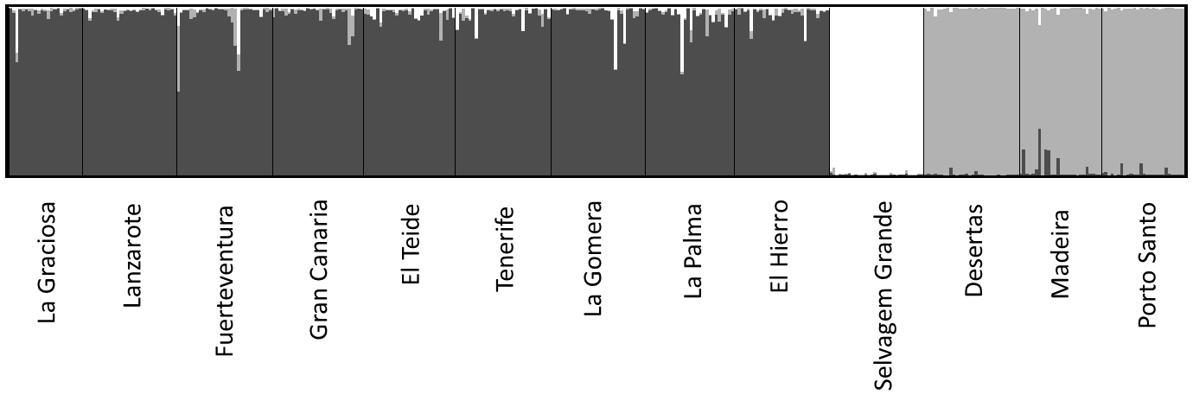
Figure S2 Variation (mean ± s.e) in morphological traits across island population of Berthelot’s pipits. Island codes are as follows: GRA La Graciosa, LZ Lanzarote, FV Fuerteventura, GC Gran Canaria, TF Tenerife, TEID El Teide, GOM La Gomera, LP La Palma, EH El Hierro, DG Deserta Grande, M Madeira, PS Porto Santo, SG Selvagem Grande.
Desertas
Gran Canaria
Madeira
Porto Santo
Selvagem Grande
El Hierro
La Palma
La Gomera
Tenerife
El Teide
Fuerteventura
La Graciosa
Lanzarote
Desertas
Gran Canaria
Madeira
Poto Santo
Selvagem Grande
El Hierro
La Palma
La Gomera
Tenerife
El Teide
Fuerteventura
La Graciosa
Lanzarote
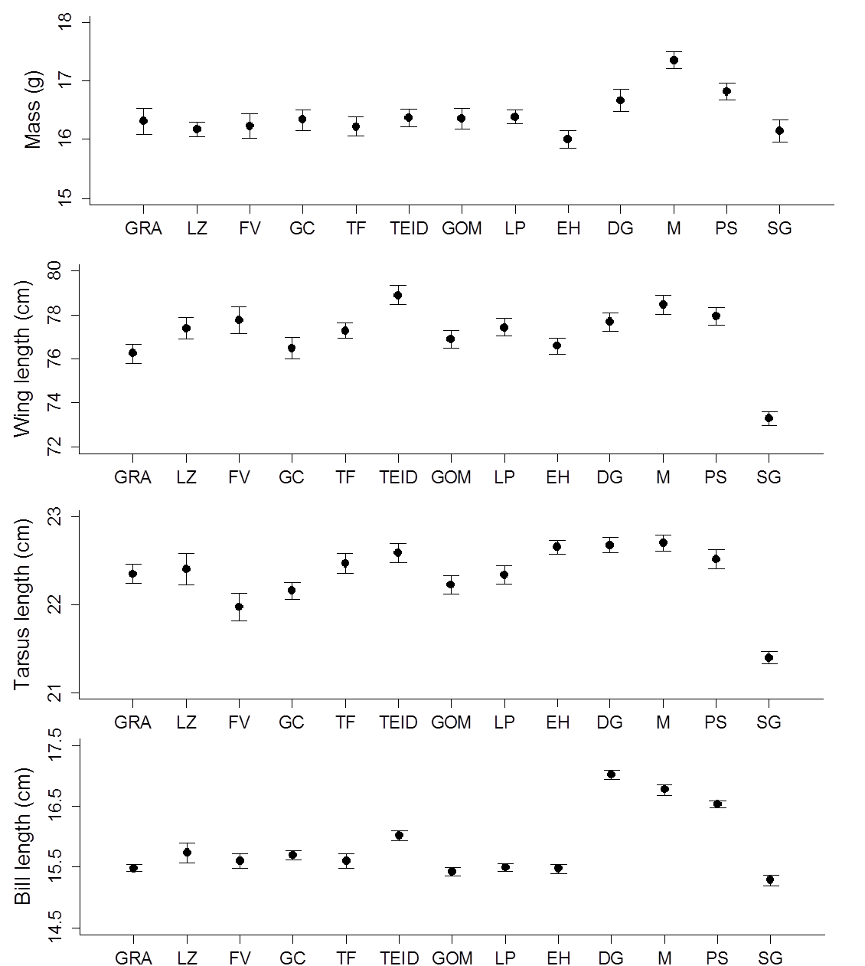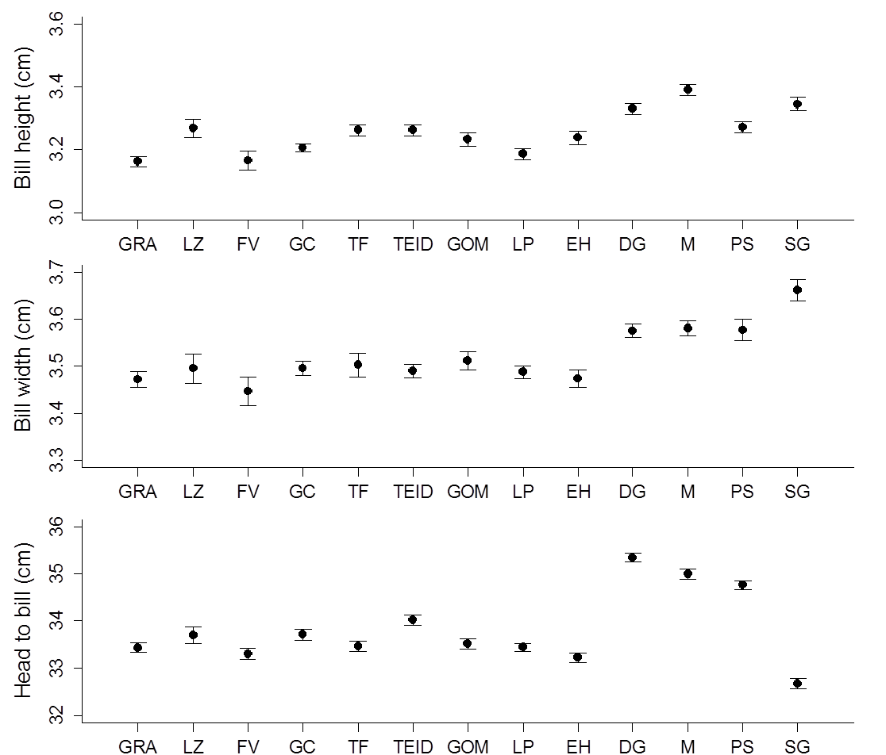

Figure S3 Pairwise morphological distance in relation to genetic distance in Berthelot’s pipit populations. Shapes correspond to the archipelagos involved in pairwise comparisons (see legend: C = Canary Islands, M = Madeira, S = Selvagens).
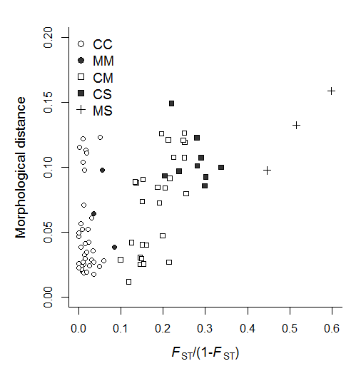
Supplementary references
Dawson D.A., Ball A.D., Spurgin L.G., Martín-Gálvez D., Stewart I.R., Horsburgh G.J., Potter J., Molina-Morales M., Bicknell A.W. & Preston S.A. (2013). High-utility conserved avian microsatellite markers enable parentage and population studies across a wide range of species. BMC genomics, 14, 176.
Dawson D.A., Hanotte O., Greig C., Stewart I.R.K. & Burke T. (2000). Polymorphic microsatellites in the blue tit Parus caeruleus and their cross species utility in 20 songbird families. Molecular Ecology, 9, 1941-1944.
Dawson D.A., Horsburgh G.J., Krupa A.P., Stewart I.R.K., Skjelseth S., Jensen H., Ball A.D., Spurgin L.G., Mannarelli M.-E., Nakagawa S., Schroeder J., Vangestel C., Hinten G.N. & Burke T. (2012). Microsatellite resources for Passeridae species: a predicted microsatellite map of the house sparrow Passer domesticus. Molecular Ecology Resources 12:501-523.
Dawson D.A., Horsburgh G.J., Küpper C., Stewart I.R.K., Ball A.D., Durrant K.L., Hansson B., Bacon I., Bird S., Klein Á., Krupa A.P., Lee J.-W., Martín-Gálvez D., Simeoni M., Smith G., Spurgin L.G. & Burke T. (2010). New methods to identify conserved microsatellite loci and develop primer sets of high cross-species utility; as demonstrated for birds. Molecular Ecology Resources, 10, 475-494.
Martinez J.G., Soler J.J., Soler M., Møller A.P. & Burke T. (1999). Comparative population structure and gene flow of a brood parasite, the great spotted cuckoo (Clamator glandarius), and its primary host, the magpie (Pica pica). Evolution, 53, 269-278.
Lima, M. D., & Lima, J. D. (2009). Investigating the multifractality of point precipitation in the Madeira archipelago. Nonlinear Processes in Geophysics, 16, 299-311.
Primmer C.R., Møller A.P. & Ellegren H. (1995). Resolving genetic relationships with microsatellite markers: a parentage testing system for the swallow Hirundo rustica. Molecular Ecology, 4, 493-498.

